Bux180 Release Notes for Production Deployment – 12/07/2013

Contents

Admin app: 3

Local Directory Management 3

View 3

Edit 5

Add 6

Partner Company Type 7

Associate Article type: 9

Updates for this release in Member App: 9

Partner App: 10

Tickets Deployed in this release: 10

Ticket :46 - copy & videos for loan officer associate portal 10

Ticket :51 - Home Related stores internal page TEST SERVER 10

Ticket :17 - Associate header display for loan 10

Ticket :44 - spelling and grammar mistakes 10

Ticket :49 - blue box in associate header 11

Ticket :53 - bux back method & non profit 11

Ticket :47 - copy & few adjustments for member site 11

Ticket :35 - spelling and grammar mistakes 11

# Admin app:

## Local Directory Management

In admin we newly added local Directory Management page, with this admin can manage all local directory.

For manage local directory it had three options

1. View
2. Edit
3. Add

### View

For viewing particular partner’s local directory admin should select partner email id then it will display all local directory details of that partner.

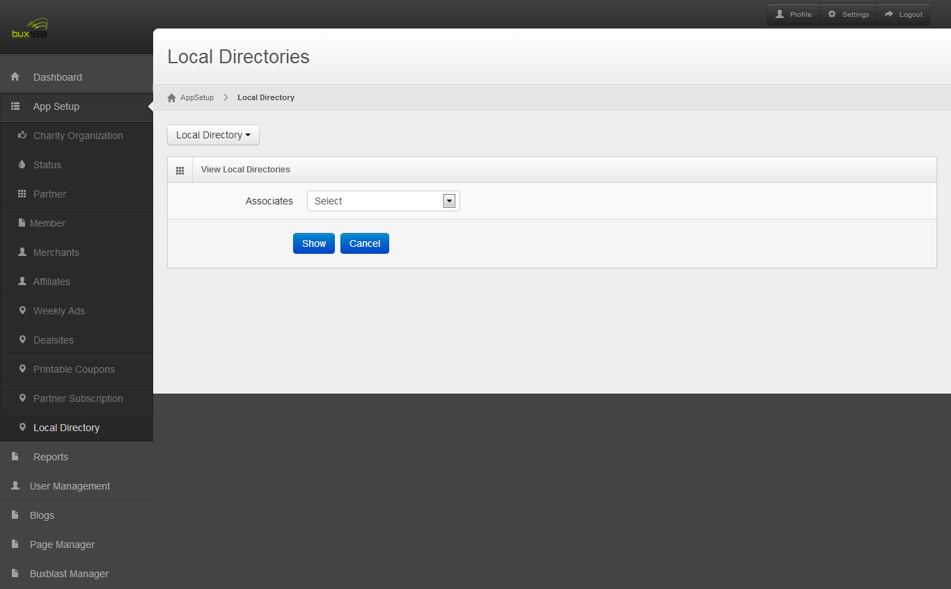

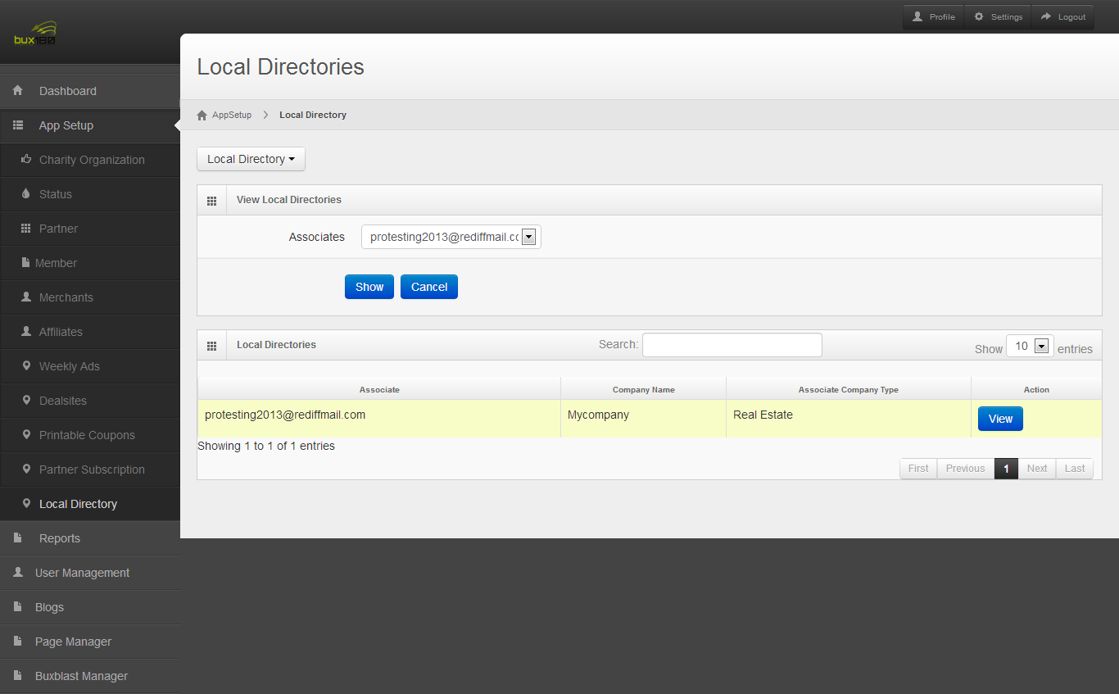

For viewing Particular Local directory admin select view button in the action column then it displays local directory details.

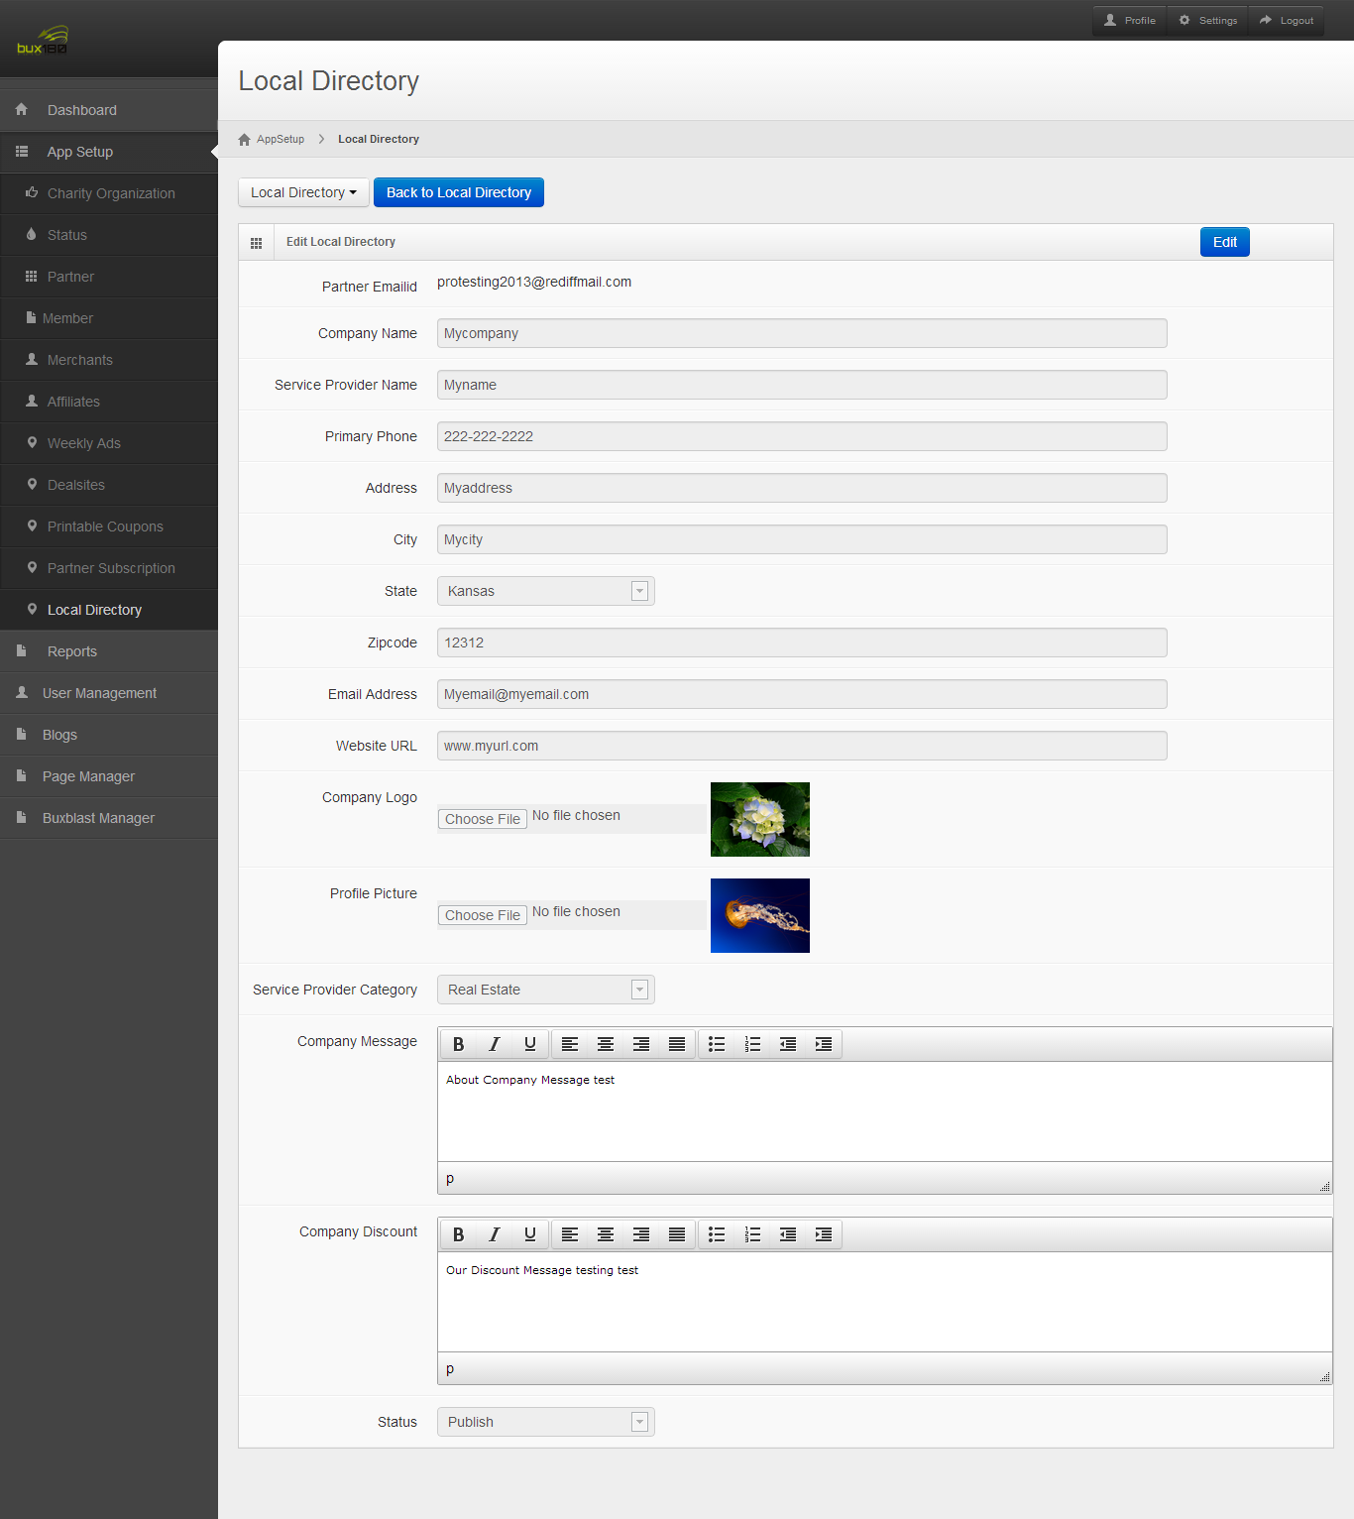

Edit:

* + In admin to edit local directory they should click edit button in the view page.
  + Here admin can edit local directory details and also they can change local directory type, status.
  + If they don’t want to edit this page they simply click cancel button it will goes to local directory index page.

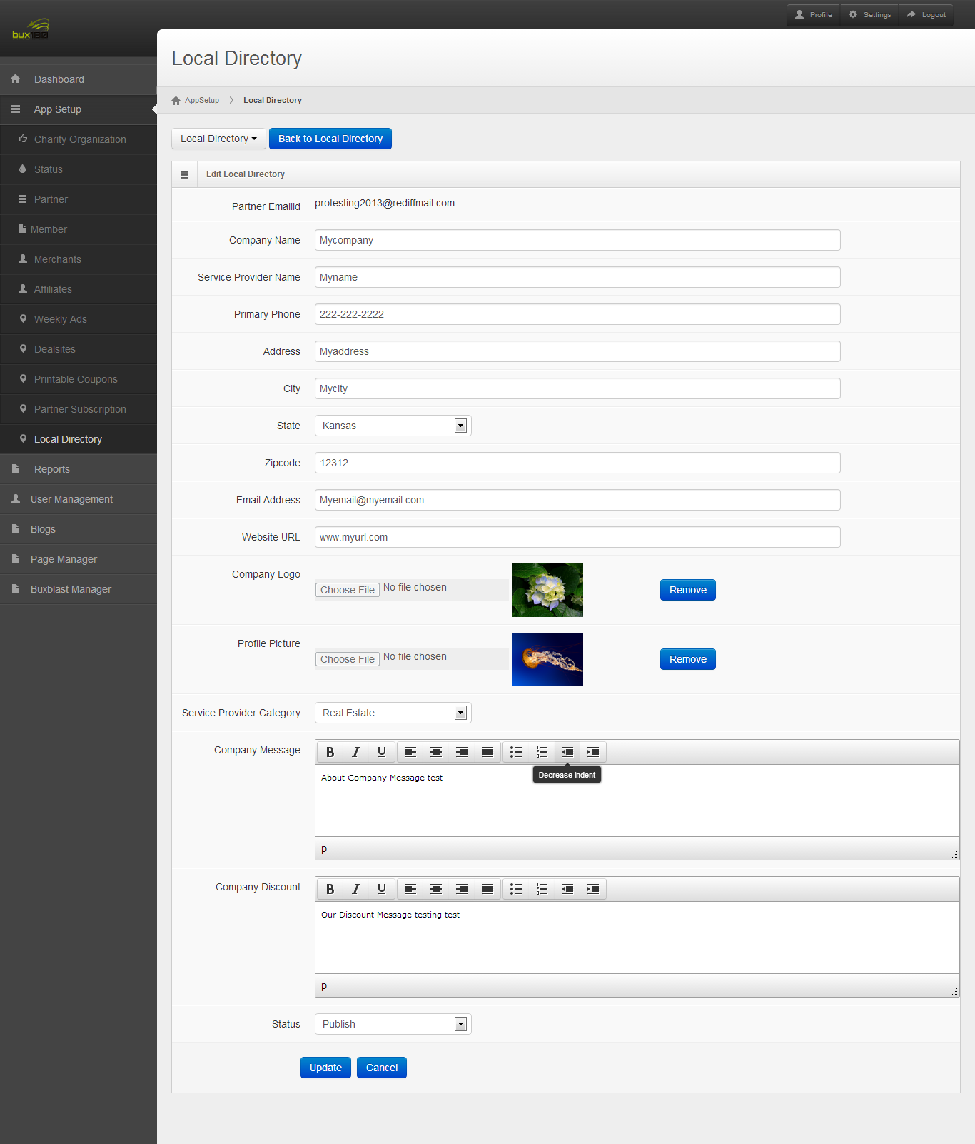

Add:

* + Admin wants to add new local directory they should select add local directory.
  + For adding local directory to partner admin should select a partner then they have fill this entire field.
  + Based on the partner type service provider category was varied.
  + After clicking submit button it will be inserted into database.

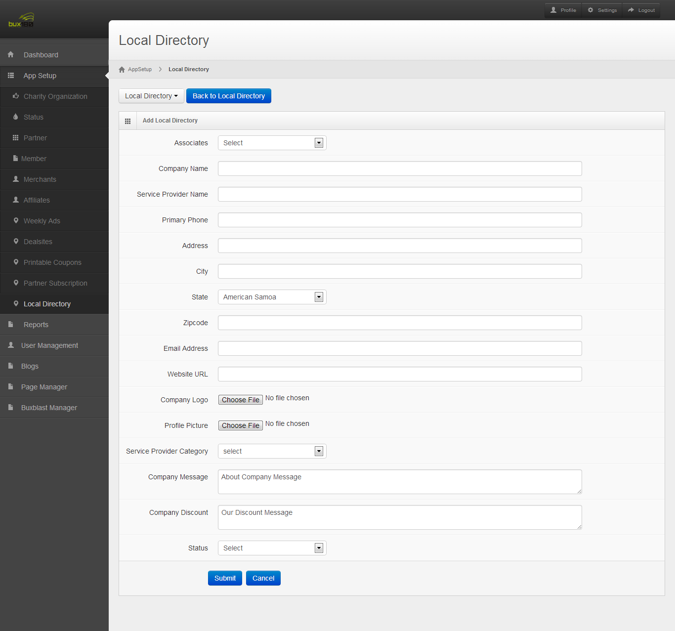

## Partner Company Type

In Partner Company type table we add two fields based on that Admin Partner Company type was changed.

In the partner Company type we add two fields Signup, status it screenshot display below.

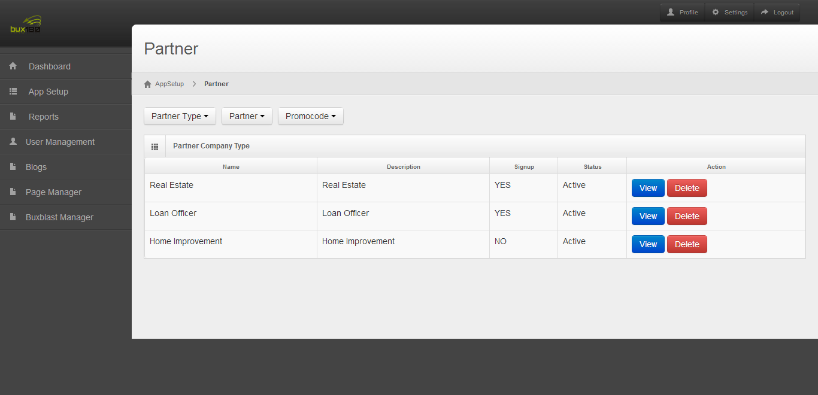

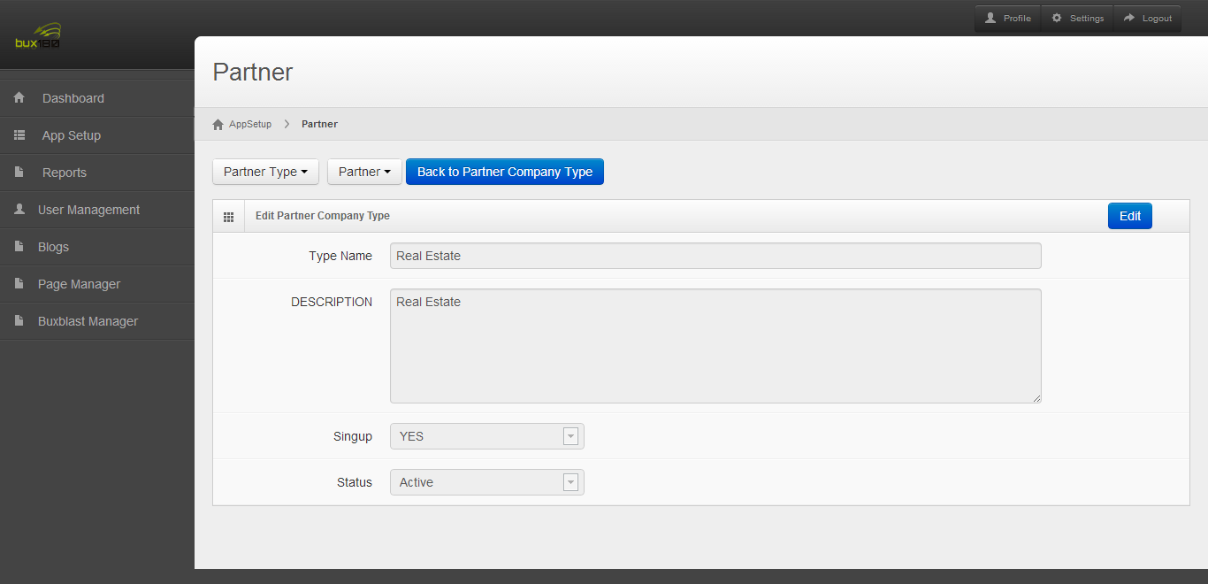

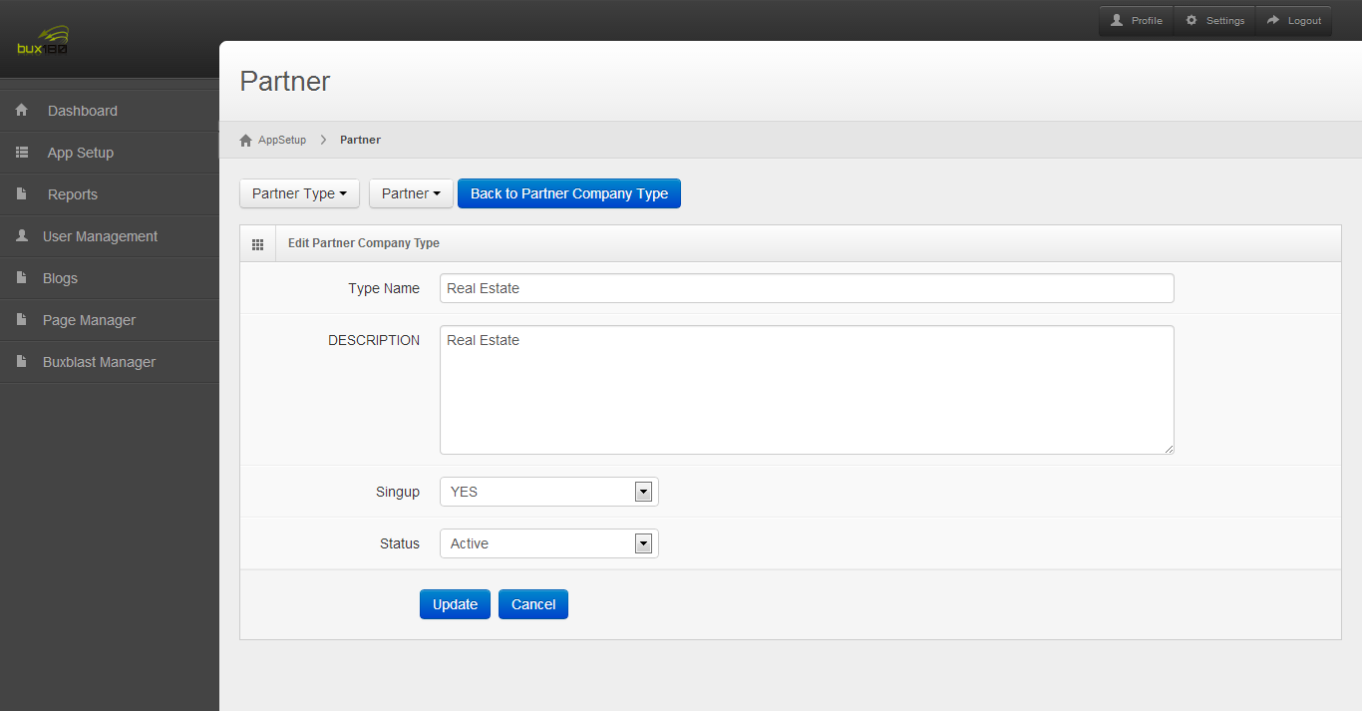

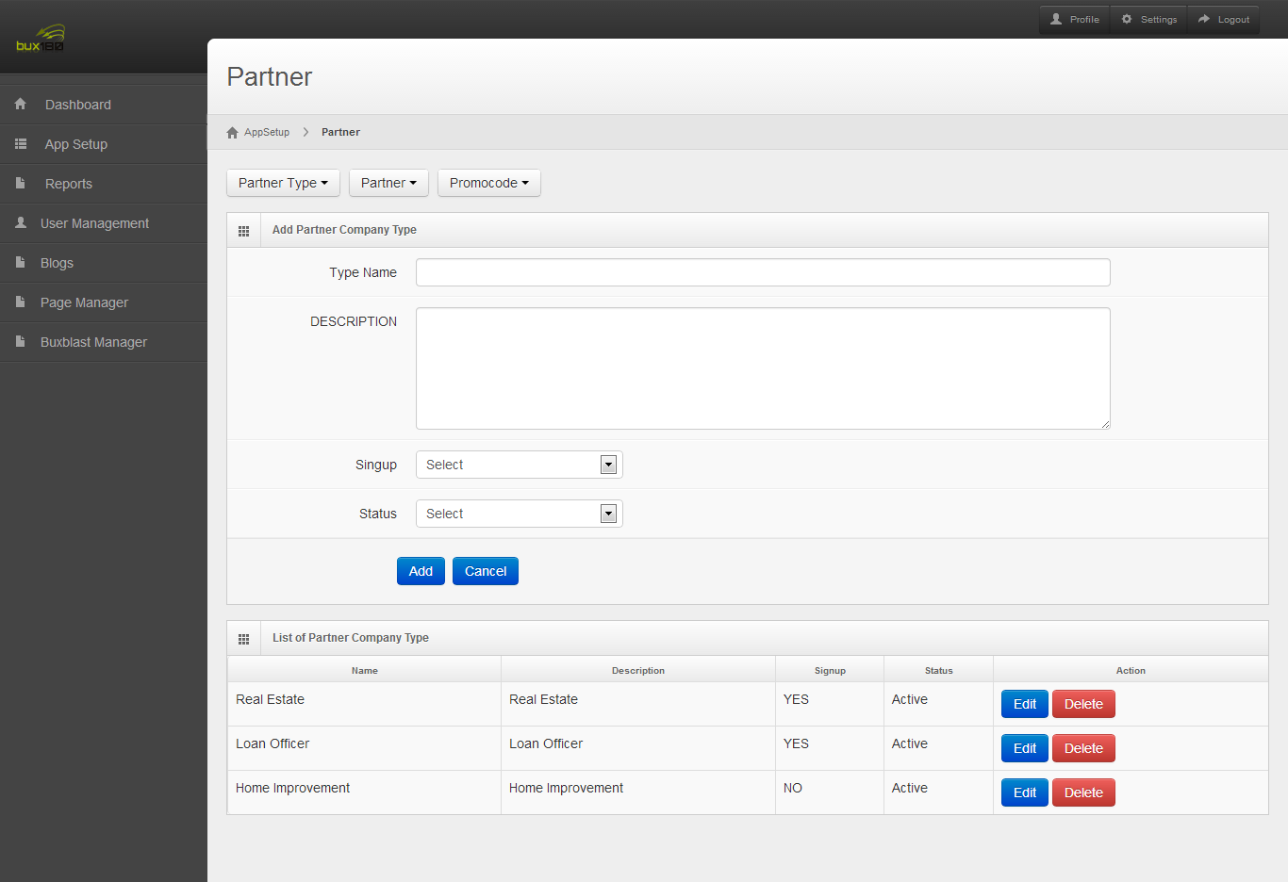

## Associate Article type:

* + Some Articles change for partner based on their company type. For that In the article table we add a field as partner_type.
  + When create an page for partner it will ask partner type this partner type will added in the article table.
  + For some page contents are some for all partner type like partner help in those pages can be created with any type of partner.
  + Some pages are varying for partner like HR Corporate Database page in those pages should create individually for each partner type.

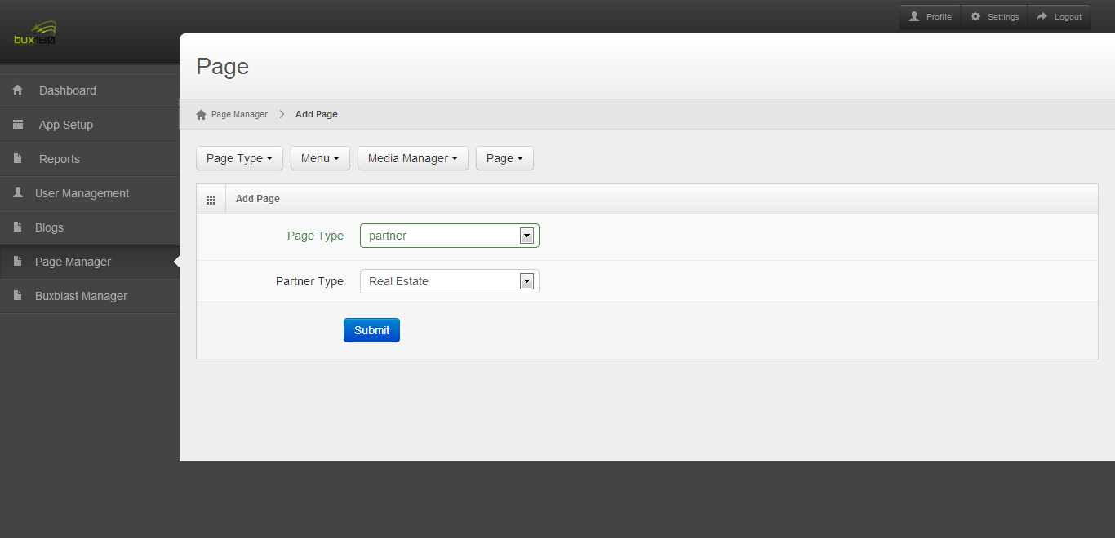

## Updates for this release in Member App:

* 1. In the member app spelling and grammar mistake was completed.
  2. In the member app all the local directory menus are displayed previously now it changes to only active service provider type based on partner company type id will be display in local directory page.
  3. In local directory page previously service provider name was not displayed as per new requirement now it will be displayed.
  4. In buxback method for HR/Main account we display company name now it will changes to charity organization account (now it was Blessings in a Backpack).
  5. In buxback method after save the buxback method we show success message.
  6. When they comes to buxback method page we show previous buxback method and its value.

## Partner App:

* 1. In the partner app spelling and grammar mistake was completed.
  2. Partner Company type was used for Service provider category and partner Company type( partner type) to differentiate Partner company type we add a field in database as signup.
  3. In partner signup page only the field which contains signup will be displayed.
  4. In partner profile page if partner was loan Officer it will display NMLS CODE and User can edit it.
  5. In Local directory display service provider category based on the partner company type.
  6. As per new requirement Service Provider name was displayed in view page and preview page.
  7. In the local directory edit page we if profile image/ company logo image was empty it will allow directly to select image if it had image after click remove button only user can select and change image.
  8. Copy paste video changes was completed.
  9. This video and text was displayed based on partner type.

# Tickets Deployed in this release:

## Ticket :46 - copy & videos for loan officer associate portal

All provided video and the content specified in the ticket for loan officer where used in the admin app for associate portal.

## Ticket :51 - Home Related stores internal page TEST SERVER

The database for home related stores that was not displaying previously for loan officer was updated.

## Ticket :17 - Associate header display for loan

## 

Header change for loan officer to display NMLS id was completed

**Ticket :52 - local directory**

Local directory in admin side was completed

## Ticket :44 - spelling and grammar mistakes

Grammar mistakes in associate portal was updated

## Ticket :49 - blue box in associate header

The blue box in associate header has been increased in length below the banner

## Ticket :53 - bux back method & non profit

When a member is a non profit the charity should be displayed with the company name of the non profit organization. When HR or main key member sign up the charity should be Blessing in a Backpack.

## Ticket :47 - copy & few adjustments for member site

Updated as per the revisions 11.28.doc

## Ticket :35 - spelling and grammar mistakes

Updated the testimonial content as per the given updates in the ticket.